**ACKNOWLEDGMENT**

The satisfaction that accompanies the successful completion of this project would be incomplete without mentioning the people who made it possible, without whose constant guidance and encouragement would have made eforts go in vain. I consider myself privileged to express gratitude and respect towards all those who has guided through the completion of projects.

I convey thanks to my project guide **Mr. Hemang J. Shah**, Computer Science & Engineering department, RNGPIT for providing encouragement, constant support and guidance which was of a great help to complete this project work successfully.

I am grateful to my external guide **Mr. Srikishan Bansal, Technical Traineer** in **Casepoint Pvt. Ltd.** for giving me the support and encouragement that was necessary for the completion of this project.

I am grateful to **Dr. Madhavi B. Desai**, Head of the Department, Computer Science & Engineering, RNGPIT for giving us the support and encouragement that was necessary for the completion of this project.

I would like to thank all the faculty members for their patience, understanding and guidance that gave me strength and will power to work through the long tedious hours for developing a project and preparing the report.

Last but not the least, I would also like to thank my colleagues, who have co-operated during the preparation of our report and without them this project has not been possible. Their ideas helped me a lot to improve my project report.

**Mistry Yash Prakashbhai (180840131030)**

Abstract

*We Scrum Kanban is a project management method that helps visualize tasks, while Scrum is a method that provides structure to the team and schedule. Kanban and Scrum are project management methodologies that complete project tasks in small increments and emphasize continuous enhancement.*

*In We Scrum Kanban the main objective of this product is to make a team transparent and honest with each other to explain this we take an example of a group/team working on a project and if any team member wants to give any type of review or feedback than they can use the retrospective board and can give comments anonymously and those who agree to that point can like that point and in the retrospective board, there are many themes that a team can select as per need most commonly used is Agile Retrospective in which there are a total of three main points What went well, What did not go well, what should be improved next. In this member can write anything they want and no one will be know that who write it so there will be transparency through this.*

TABLE OF CONTENTS

Acknowledgment v

Abstract…... vi

List of Figures ix

List of Tables x

Chapter 1 Overview 1

1.1 Overview of the Company 1

1.2 Different Product 1

1.3 Orgnization chart 2

1.4 Capacity of the Plant 2

Chapter 2 Overview of Different Departments and Layout of Process 3

2.1 Departments Overview 3

2.2 List the technical specifications of major equipment used in each department. 5

2.3 Schematic Layout for Development of End Product 7

2.4 Details of each Stages 7

Chapter 3 Introduction to Internship and Internship Management 9

3.1 Internship Summary 9

3.2 Purpose 9

3.3 Objective 9

3.4 Scope 9

3.5 Technology and Literature 10

3.6 Internship Planning 10

3.6.1 Internship Approach 10

3.6.2 Internship Effort and Time 10

3.6.3 Roles and Responsibilties 10

3.6.4 Group Dependencies 11

3.7 Internship Scheduling 11

Chapter 4 System Analysis 12

4.1 Study of Current System 12

4.2 Problem and Weakness of Current System 12

4.3 Hardware and Software Requirement 12

4.4 Selection of Methodology 12

4.5 System Modules 14

4.5.1 Scrum Master 14

4.5.2 User 14

4.6 Functional Requirements 15

4.7 Non Functional Requirements 15

Chapter 5 System Design 16

5.1 Use Case Diagram 16

5.2 Sequence Diagram 17

5.3 Activity Diagram 18

5.4 Class Diagram 20

5.5 Database Schema 21

5.6 Data Flow Diagram 25

5.7 ER Diagram 27

Chapter 6 Implementation 28

6.1 Hardware and Software Requirements 28

6.2 Snapshots 28

Chapter 7 Testing 35

Chapter 8 Conclusion and Discussion 38

8.1 Overall Analysis of Internship 38

8.2 Date of Surprise visit by institute mentor 38

8.3 Dates of Continues Evaluation 38

8.4 Problem Encountered and Possible solution 38

8.5 Summary of Internship 38

8.6 Conclusion of Project 39

References 40

# List of Figures

Figure 1.1 Organization Chart 2

Figure 2.1 Layout of operations for development 7

Figure 3.7 Internship Scheduling 11

Figure 4.1 Agile Methodology 13

Figure 4.2 Agile-Scrum Methodology 14

Figure 5.1 Use Case Diagram 16

Figure 5.2 Sequence Diagram 17

Figure 5.3 Sequence Diagram 17

Figure 5.4 Activity Diagram 18

Figure 5.5 Activity Diagram 19

Figure 5.6 Class Diagram 20

Figure 5.7 DFD Level-0 25

Figure 5.8 DFD Level-1 25

Figure 5.9 DFD Level-1 26

Figure 5.10 ER Diagram 27

Figure 6.1 Sign Up 28

Figure 6.2 Sign In 29

Figure 6.3 Select Retrospective 29

Figure 6.4 User Profile 30

Figure 6.5 Admin User Page 30

Figure 6.6 Forget Password Page 31

Figure 6.7 Admin Dashboard Page 31

Figure 6.8 Create Retrospective 32

Figure 6.9 Select Retrospective 32

Figure 6.10 Resource management 33

Figure 6.11 Team Configuration 33

Figure 6.12 Iteration Management 34

Figure 6.13 Play Retrospective 34

**List of Tables**

Table 5.1 User Table 21

Table 5.2 Role Table 21

Table 5.3 Team Table 22

Table 5.4 Iteration Table 22

Table 5.5 Retro Board Table 22

Table 5.6 Board Category Table 23

Table 5.7 Retro Count Table 23

Table 5.8 Like Table 24

Table 5.9 Board History Table 24

Table 7.1 Test Cases 35

# 

# Overview

## Overview of the Company

Company Name – Casepoint Pvt. Ltd.

* Casepoint is a U.S. based Software-as-a-Service (SaaS) technology company focused on the legal industry.
* Casepoint is headquartered in Tysons, Virginia (Washington, DC Metro area), but has an international subsidiary based in Surat, Gujarat, India.
* It was founded in 2008.
* Mission is to enable our clients to uncover actionable insights at enterprise scale.
* Vision is to empower the global Casepoint community with intelligent technology while achieving meaningful experience and outcomes.
* Casepoint has mature and well-defined processes and methodologies based on the highest international standards for project management, agile software development, human resources, and IT infrastructure and security.

## Different Product

* Legal
* Litigation
* eDiscovery
* Investigations
* Compliance
* Software Development
* Legal Technology
* Litigation Support & Legal IT.

## Orgnization chart

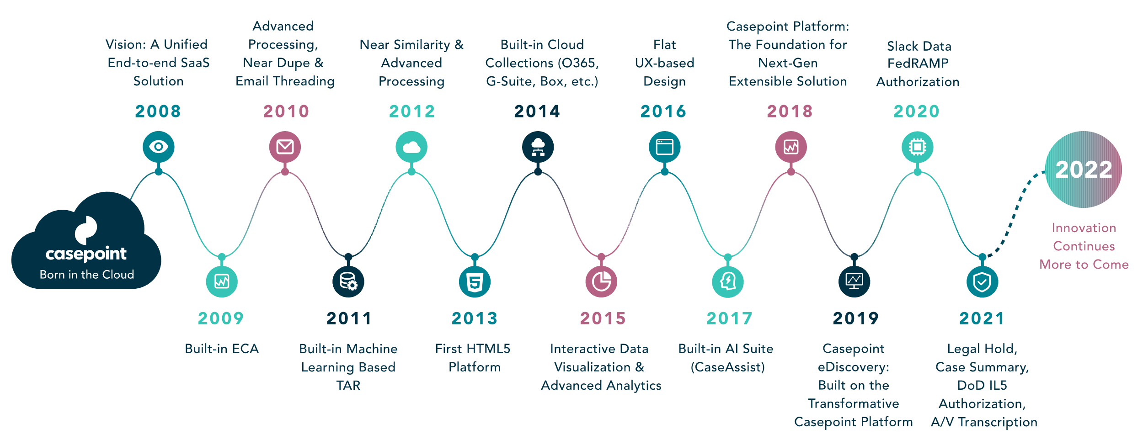

**Figure 1.1** **Organization Chart**

## Capacity of the Plant

Company Size – 201-500 employees.

# OverView of Differents Departments And Layout of Process

## DETAILS ABOUT THE WORK BEING CARRIED OUT IN EACH DEPARTMENT

**2.1.1. Business Analyst:** Business Analyst team is an integral part of the software delivery team product flow starts from this department. They will join clients, software engineers, testers and product managers in the brainstorming sessions and identify the best solution to the most critical business problems.

* Brainstorming new ideas and identifying the best solution.
* Identify the business goals.
* Gathering and evaluating client requirements, and write user stories and acceptance criteria.

**2.1.2. Product UI-UX:** After getting the requirements form the, this department handles client’s requirements very carefully and implements client’s ideas into design.

* Gathering and evaluating user requirements, in collaboration with product managers and engineers
* Illustrating design ideas using storyboards, process flows and sitemaps
* Designing graphic user interface elements, like menus, tabs and widgets.

**2.1.3. Product Development:** It is divided into two sections 1) Front-End 2) Back-End

1) Front-End Department: A front-end department is responsible for implementing visual elements that users see and interact with in a web application. They are usually supported by back-end web developers.

* Ensure the technical feasibility of UI/UX designs
* Build reusable code and libraries for future use
* Develop new user-facing features
* Optimize application for maximum speed and scalability
* Collaborate with other team members and stakeholders

2) Back-end Department: A back-end web developer is responsible for server-side web application logic and integration of the work front-end web developers do. Back-end developers usually write web services and APIs used by front-end developers and mobile application developers.

* Integration of user-facing elements developed by a front-end developer with server-side logic
* Implementation of security and data protection
* Design and implementation of data storage solutions
* Building reusable code and libraries for future use

**2.1.4 Data Analysis & Processing:** Data analysis is the process of cleaning, changing, and processing raw data, and extracting actionable, relevant information that helps businesses make informed decisions. The procedure helps reduce the risks inherent in decision-making by providing useful insights and statistics, often presented in charts, images, tables, and graphs.

**2.1.5 Product Solutions:** This Department ensures that all department tasks in the company are functioning smoothly and provides troubleshooting.

**2.1.6 Product QA:** The main goal of the Quality Assurance (QA) department is to help create a quality product. Their job is not only bug searching and regular product testing, but to also prevent defects accordingly. They ensure the high quality of the development process and its results.

* Testing the product during all phases of the software development lifecycle (SDLC)
* Identifying weaknesses and inconsistencies in the product.
* Helping to identify project requirements.
* Providing the team with complete information on product quality.

**2.1.7. Finance & Administration:** The finance department is at the centre of any organization, it is also responsible for ensuring the efficient financial management and financial controls necessary to support all business activities. And The admin department provides valuable services, enabling work processes to operate seamlessly and decision-makers to focus on value-added tasks and responsibilities. Administrative roles include day-to-day tasks that keep an organization running smoothly and efficiently.

**2.1.8. Product DevOps:** The primary roles and responsibilities of a DevOps team are to communicate effectively, improve visibility across the CI/CD pipeline and constantly learn new things. A drive for continuous improvement will be at the core of any efficient DevOps organization. Every person in a DevOps-centric organization should be highly focused on developing new features and services quickly without sacrificing reliability or customer experience.

**2.1.9. Marketing & Branding:** The main goal of this department to ensure that their company’s products, services, and product lines resonate with current or potential customers.

**2.2.0. Human Resources:** HR department is tasked with maximizing employee productivity and protecting the company from any issues that may arise within the workforce. HR responsibilities include compensation and benefits, recruitment, firing, and keeping up to date with any laws that may affect the company and its employees.

* + Managing and using people effectively
  + Tying performance appraisal and compensation to competencies
  + Increasing the innovation, creativity, and flexibility necessary to enhance competitiveness
  + Managing the implementation and integration of technology through improved staffing, training, and communication with employee

## LIST OF MAJOR TOOLS AND TECHNOLOGIES USED IN EACH DEPARTMENT

1. Business Analyst:

* Azure DevOps
* Google Docs
* Google Sheets

2. Product UI-UX:

* Adobe XD
* Figma
* Invision

3. Product Development-

Front-End:

* HTML
* CSS
* JavaScript /jQuery
* Kendo UI
* ReactJS
* AngularJS
* Visual Studio Code

Back-End:

* .NET MVC
* PostgreSQL
* MongoDB
* Redis
* RabbitMQ
* Elastic Search
* N-Cache
* Microsoft Visual Studio

4. Data Analysis & Processing:

* Python
* Microsoft Excel
* Power Bi

5. Product QA:

* Chromium Dev Tools
* Java Programming
* Selenium
* Qmetry

6. Product DevOps:

* Azure DevOps Server

7. Human Resource:

* Keka

## SCHEMATIC LAYOUT ABOUT SEQUENCE OF OPRATIONS FOR DEVELOPMENT OF END PRODUCT

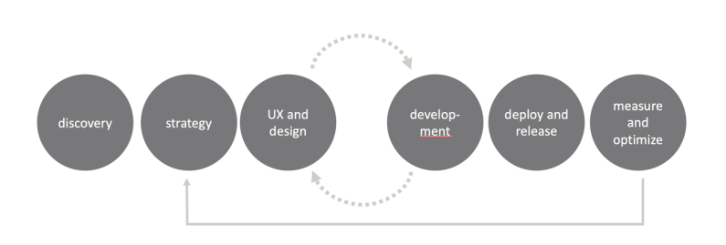

**Figure 2.1 Layout of Operations for Development**

Above Chart/Figure Show how the work is carried out in organization and in figure as we can see the flow the very first step will be the discovery after that planning/strategy phase and then design and development phase there might me some back and forth situation between design and development because of requirements changes after that deployment and final stage will be measurement and optimization that will repeat whole cycle if there is any optimization.

## DETAILS OF EACH STAGE:

***a. Discovery:***

Discovery is the first phase of the service design and delivery process. Doing user research during Discovery is critical to understand the problem you need to solve for your users. When you know their challenges, needs and wants, you gain insights into what aspects of the problem you will need to prioritise. Discovery usually takes between four to eight weeks.

***b. Strategy:***

Planning and testing a project must be directly linked to its strategy. In this phase, you put the project under the microscope and analyse all the details. It involves making strategic decisions on who will be assigned what duties in the project, designing a timetable and setting timescales, allocating resources and putting in place measures that will ensure that forecasts made in the initiation stages are met. Mapping out the project in well-articulated details gives the project bigger chances of success.

***c. UX and Design:***

Project design is an early phase of the project where a project's key features, structure, criteria for success, and major deliverables are all planned out. The aim is to develop one or more designs that can be used to achieve the desired project goals.

***d. Development:***

Development stage refers to the first phase in the life cycle of a new business. During the development stage, companies focus on establishing themselves through activities such as market research, product development, and the construction of new manufacturing facilities.

***e. Deploy and Release:***

Release and Deployment aims to plan, schedule and control the movement of releases to test and live environments. The primary goal of this process is to ensure that the integrity of the live environment is protected and that the correct components are released.

***f. Measure and optimize:***

We have a process of systematically tracking user behaviour on your website and mobile app into analytical and marketing platforms. Effective collection, measurement, and validation contribute to enhanced marketing impact.

# introduction to internship and

# internship management

## Internship Summary

During an internship I have learned many new web development programming languages. I have learned both back-end and front-end programming with hybrid module. During training period, developed small application with front & back end. E.g., Login & Registration, CRUD with or without Entity framework, Shopping Cart etc. Also learned about Agile Methodology and Scrum Framework and worked accordingly in the project. One of the best part of an organization is career progress of employees. During an internship also attended sessions on “College to Corporate” life and understood corporate etiquette as well as workshop on “The Ultimate Agile Scrum Kickstart”. While working here I feel like surrounded by very passionate people.

## Purpose

## The purpose was to gain real time project experience. To learn and work new technologies.

## To put my knowledge about web development into practice and enhance my skills in web development.

## Objective

* The main objective of an internship was to analyse and implement more about web development with front-end and back-end.

## Scope

* To gain first-hand exposure of working in real word.
* Analyze and apply skills, knowledge and theoretical practice in projects.

## Literature Review

* During the training of an internship, I have learned all the technologies as and implement various small application using those tools and technologies. During this I have also gone through various documentations [3] and videos [4] to get insights and implement those. For project also learned about agile methodology [5] and attended various seminar and actively participated for the same organize by the company.

## Internship Planning

* The entire internship program was well planned by company.
* They gave basic introduction of company and brief overview of entire internship.
* They also communicate about personal goals, objectives and visa-versa.
* After that desk and system was assigned in order to work there.
  1. **Internship Approach**
     + - * The way entire internship carried out was in learning approach.
         * In entire internship half period was assigned for training and another half was assigned for project.
         * For training, technical trainer was allocated and for project work sprints were organized to work with team.
  2. **Internship Effort and Time**
     + - * Internship Efforts:

I have set the clear goals for this.

Made new connections among the company.

Kept practising about training work.

Sought out growth opportunities

* + - * + Time

It was for duration three months internship.

Staring Date:

Ending Date:

* 1. **Roles and Responsibilities**
     + - * Have been assigned three roles during this in project implantation.

Database and Tester [Sprint 1]

Have been create Database and Testing the Module 1.

Developer [Sprint 2]

Have been developed the retrospective creation window.

Developer[Sprint 3]

Have been developed the whole Dashboard page.

* 1. **Group Dependencies**
     + - * The entire project has been developed in team with five members.

## Internship Scheduling

**Figure 4.1 Internship Scheduling**

# System analysis

## Study of Current System

* Current System is doing Retrospective by Physical Gathering or by using third party Application.
* Due to physical appearance the teammember’s can’t be transpearent with each other.
* Because of that Problems not come out between team, So team efficiency get reduced.

## Problem and Weakness of Current System

* The efficiency of team got reduced.
* The themes are not customizable.

## Hardware and Software Requirement

* **Hardware**
  + Processor: x64-based processor
  + RAM: Minimum 4 GB
* **Software**
  + Microsoft Visual Studio
  + PostgreSQL
  + RabbitMQ
  + Redis Cache
  + Azure DevOps

## Selection of Methodology

* **Agile model:**
* Agile modeling is a methodology for modeling and documenting software systems based on best practices
* Agile methodology overcomes the risk of spending a lot of time if there are any changes required. It allows teams to work directly with clients, instead of working with other teams. This provides a clear outcome with a focused goal and in an incremental way.
* Advantages of Agile model
  + Customer satisfaction by rapid, continuous delivery of useful software.
  + People and interactions are emphasized rather than process and tools. Customers, developers and testers constantly interact with each other.
  + Face-to-face conversation is the best form of communication.
  + Continuous attention to technical excellence and good design.
  + Regular adaptation to changing circumstances.
  + Even late changes in requirements are welcomed

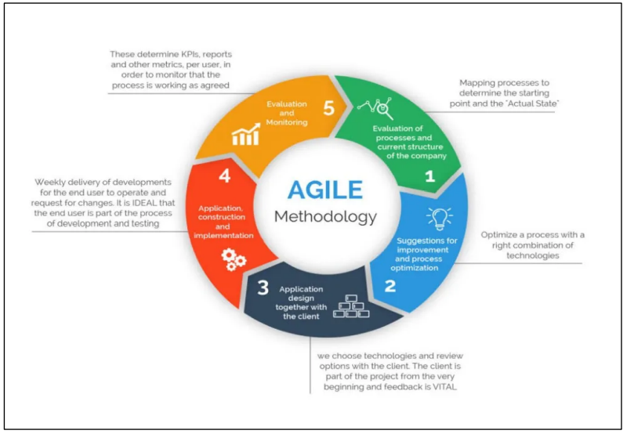

**Figure 4.1 Agile Methodology**

* **Agile Scrum:**
* Agile Scrum Methodology is a sprint-based system for managing software projects, whose goal is to deliver the highest value to stakeholders. Agile Scrum Methodology, a specially treated project management system, works on incremental development in product development. The iterations are divided into manageable time slabs, each of about four-week Sprints. Every goal-driven Sprint offers vital features that constructively develop a complete product. In subsequent sprints, add-on features and enhancements based on customer and team feedback are built into the product.

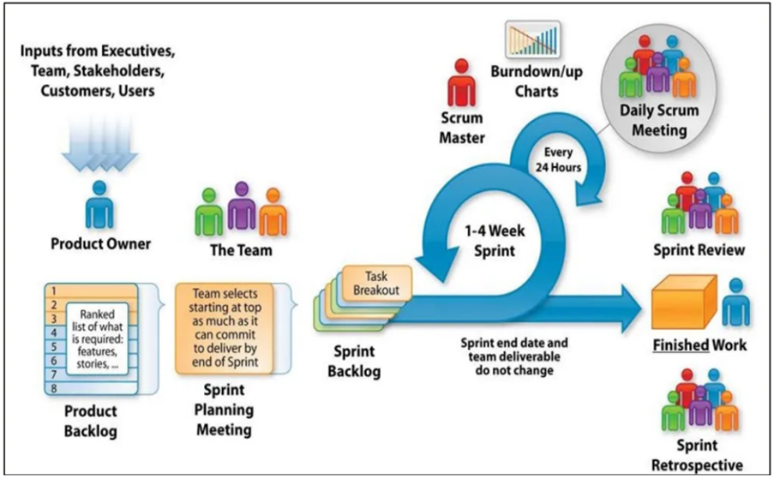

**Figure 4.2 Agile-Scrum Methodology**

## System Modules

Scrum Master, User Role.

### Scrum Master

* Manage Password
* ManageResource
* ManageIteration
* ManageTeam
* CreateRetro-Boar
* PlayRetrospective
* Logout.

### User

* Manage Password
* Boar
* PlayRetrospective
* Logout.

## Functional Requirements

Sign Up, Login, Forget Password, User Profile, Email Functionality, Retrospective-Page, Sprint Retrospective Boards, Team Configuration, Iteration Management, Resource Management, Resource Login, Dashboard, Error Log & Log Management,

## Non Functional Requirements

Internet Connection, Browser, Desktop/Laptop.

# System Design

## Use Case Diagram

A use case diagram is a graphical depiction of a user's possible interactions with a system.

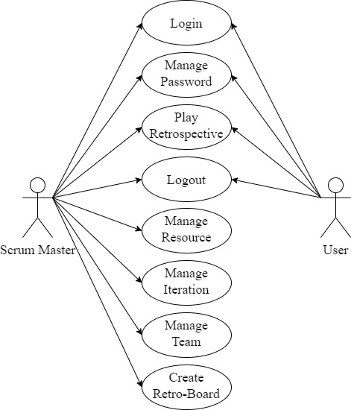

Figure 5.1 Use Case

## Sequence Diagram

A sequence diagram or system sequence diagram shows object interactions arranged in time sequence in the field of software engineering.

Figure 5.2 Sequence Diagram

Figure 5.3 User Sequence

## Activity Diagram

Activity diagrams are graphical representations of workflows of stepwise activities and actions with support for choice, iteration and concurrency.

Figure 5.4 Activity Diagram

Figure 5.5 Activity Sequence

## Class Diagram

In software engineering, a class diagram in the Unified Modeling Language is a type of static structure diagram that describes the structure of a system by showing the system's classes, their attributes, operations, and the relationships among objects.

Figure 5.6 Class Diagram

## Database Schema

Table 5.1 User Table

|  |  |  |  |  |
| --- | --- | --- | --- | --- |
| **Column Name** | **Data Type** | **Size** | **Constraint** | **Description** |
| sale_id | INT | N/A | Primary Key | Sale Id |
| order_id | VARCHAR | 20 | --- | Order Id |
| payment_type | ENUM | 20 | --- | Payment Type |
| grand_total | FLOAT | 10 | --- | Payment Amount |
| shipping_address | VARCHAR | 200 | --- | Shipping Address |
| awb_code | INT | N/A | --- | AWB Number |
| delivery_person_id | INT | N/A | --- | Delivery Person Id |
| Manager_id | INT | N/A | --- | Manager Id |
| assign | BOOLEAN | N/A |  | Order assign or not |
| assign_date | DATE | N/A | --- | Order assign date |
| delivery_type | ENUM | N/A | --- | Delivery Type |
| delivery_status | ENUM | N/A | --- | Delivery Status |
| delivered_date | DATE | N/A | --- | Delivered Date |
| comments | VARCHAR | 100 | --- | Comments |

Table 5.2 Role Table

|  |  |  |  |  |
| --- | --- | --- | --- | --- |
| **Column Name** | **Data Type** | **Size** | **Constraint** | **Description** |
| c_roleid | INT | N/A | Primary Key | Id No. |
| c_rolename | VARCHAR | N/A | --- | Admin/User |

Table 5.3 Team Table

|  |  |  |  |  |
| --- | --- | --- | --- | --- |
| **Column Name** | **Data Type** | **Size** | **Constraint** | **Description** |
| c_teamid | INT | N/A | Primary Key | Team Id |
| c_teamname | VARCHAR | 50 | --- | Team Name |
| c_createdby | INT | N/A | Foreign Key | Created By |
| c_teamcreationdate | DATE | N/A | --- | Creation Date |
| c_scrummaster | INT | N/A | Foreign Key | Scrum Master |
| c_isactive | INT | N/A | --- | Is Active |

Table 5.4 Iteration Table

|  |  |  |  |  |
| --- | --- | --- | --- | --- |
| **Column Name** | **Data Type** | **Size** | **Constraint** | **Description** |
| c_teamid | INT | N/A | Primary Key | Team Id |
| c_teamname | VARCHAR | 50 | --- | Team Name |
| c_createdby | INT | N/A | Foreign Key | Created By |
| c_teamcreationdate | DATE | N/A | --- | Creation Date |
| c_scrummaster | INT | N/A | Foreign Key | Scrum Master |
|  |  |  |  |  |

|  |  |  |  |  |
| --- | --- | --- | --- | --- |
| **Column Name** | **Data Type** | **Size** | **Constraint** | **Description** |
| warehouse_id | INT | N/A | Primary Key | Warehouse Id |
| warehouse_name | VARCHAR | 20 | --- | Warehouse Name |
| warehouse_location | VACHAR | 20 | --- | Warehouse Location |

Table 5.5 Retro Board Table

Table 5.6 Board Category Table

|  |  |  |  |  |
| --- | --- | --- | --- | --- |
| **Column Name** | **Data Type** | **Size** | **Constraint** | **Description** |
| c_categoryid | INT | N/A | Primary Key | Category Id |
| c_categoryname | VARCHAR | 50 | --- | Iteration Id |
| c_boardid | INT | N/A | Foreign Key | Board Id |
| c_iconname | VARCHAR | 50 | --- | Icon Name |

Table 5.7 Retro Count Table

|  |  |  |  |  |
| --- | --- | --- | --- | --- |
| **Column Name** | **Data Type** | **Size** | **Constraint** | **Description** |
| c_commentid | INT | N/A | Primary Key | Comment Id |
| c_boardid | INT | N/A | Foreign Key | Board Id |
| c_categoryid | INT | N/A | Foreign Key | Category Id |
| c_teamid | INT | N/A | Foreign Key | Team Id |
| c_userid | INT | N/A | Foreign Key | User Id |
| c_iterationid | INT | N/A | Foreign Key | Iteration Id |
| c_comment | VARCHAR | 300 | --- | Comments |
| c_likecount | INT | N/A | --- | Like Counter |

Table 5.8 Like Table

|  |  |  |  |  |
| --- | --- | --- | --- | --- |
| **Column Name** | **Data Type** | **Size** | **Constraint** | **Description** |
| c_likeid | INT | N/A | Primary Key | Like Id |
| c_userid | INT | N/A | Foreign Key | User Id |
| c_commentid | INT | N/A | Foreign Key | Comment Id |

Table 5.9 Board History Table

|  |  |  |  |  |
| --- | --- | --- | --- | --- |
| **Column Name** | **Data Type** | **Size** | **Constraint** | **Description** |
| del_person_id | INT | N/A | Primary Key | Delivery Person Id |
| name | VARCHAR | 20 | --- | Delivery Person Name |
| location | VARCHAR | 20 | --- | Delivery Person Location |
| email | VARCHAR | 20 | --- | Delivery Person Email |
| password | VARCHAR | 20 | --- | Delivery Person Password |
| Is_Active | BOOLEAN | N/A | --- | Active Or Not |
| manager_id | INT | N/A | Foreign Key | Manager Id |

|  |  |  |  |  |
| --- | --- | --- | --- | --- |
| **Column Name** | **Data Type** | **Size** | **Constraint** | **Description** |
| manager_id | INT | N/A | Primary Key | Warehouse Manager Id |
| name | VARCHAR | 20 | --- | Warehouse Manager Name |
| location | VARCHAR | 20 | --- | Warehouse Manager Location |
| email | VARCHAR | 20 | --- | Warehouse Manager Email |
| password | VARCHAR | 20 | --- | Warehouse Manager Password |
| Is_Active | BOOLEAN | N/A | --- | Active Or Not |
| warehouse_id | INT | N/A | Foreign Key | Warehouse Id |

## Data Flow Diagram

A data-flow diagram is a way of representing a flow of data through a process or a system.

Figure 5.7 DFD Level-0

Figure 5.8 DFD Level-1

Figure 5.9 DFD Level-1

## ER Diagram

ER Diagram stands for Entity Relationship Diagram, also known as ERD is a diagram that displays the relationship of entity sets stored in a database. In other words, ER diagrams help to explain the logical structure of databases. ER diagrams are created based on three basic concepts: entities, attributes and relationships.

Figure 5.10 E-R Diagram

# Implementation

## Hardware and Software Requirements

Visual Studio Software to implement our project.

Front-end: KendoUI

Back-end: C#, .NET MVC

Database: PostgreSQL

Radis and RabbitMQ to implement notifications.

Agile methodology with Scrum framework is used to implement the project in step by step manner with the help of sprints oject.

## Snapshots

* **Sign Up**

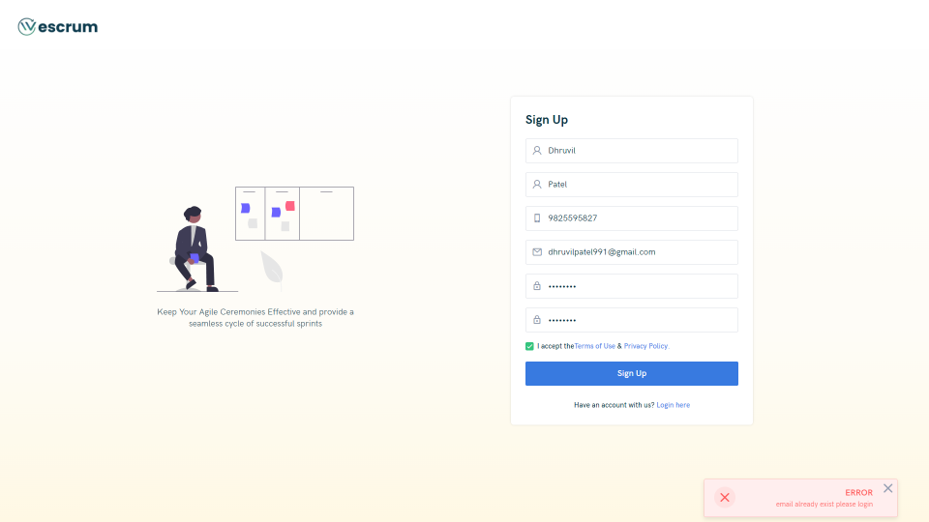

Figure 6.1 Sign Up Page

User will able to Register he/she.

* **Sign In**

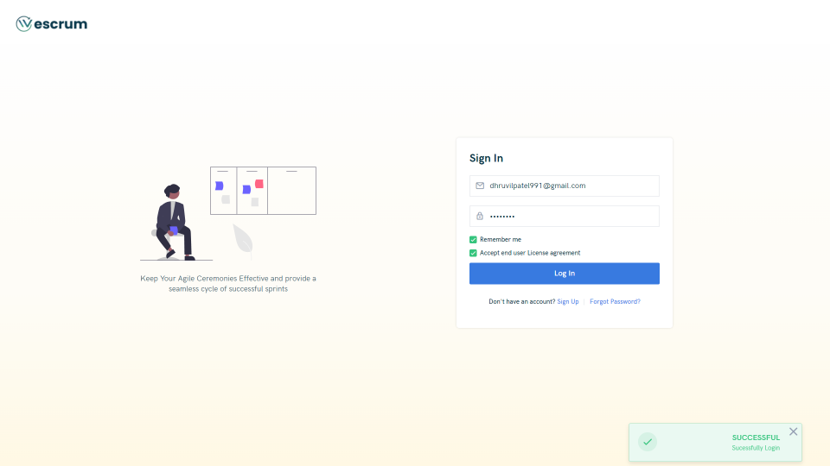

Figure 6.2 Sign In Page

After completion of Registration a mail will be given to the user in which there will a activation link which will redirect to Sign In.

* **Select Retrospective**

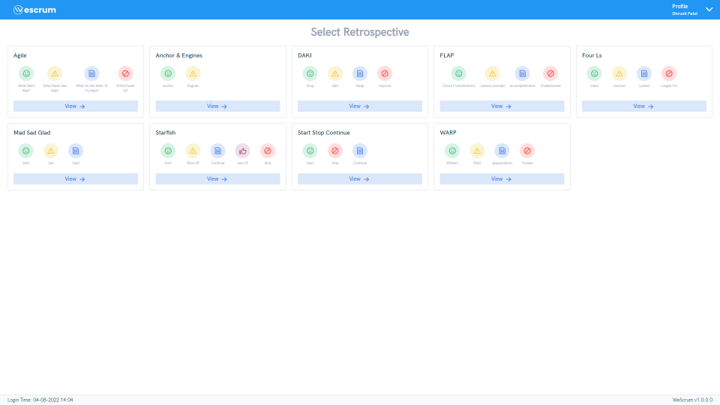

Figure 6.3 Select Retrospective Page (User Side)

User side of the Landing Page.

* **User Profile**

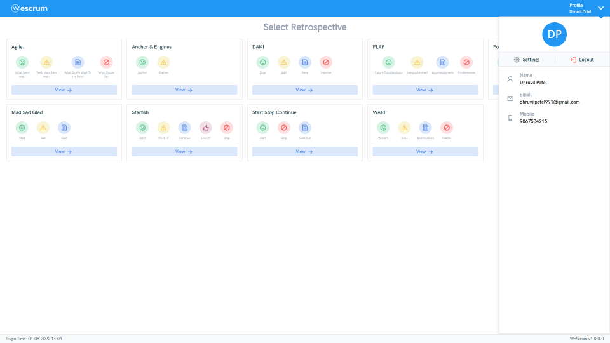

Figure 6.4 User Profile Page

User Profile with user details and they can update their details and can change password.

* **Admin Side**

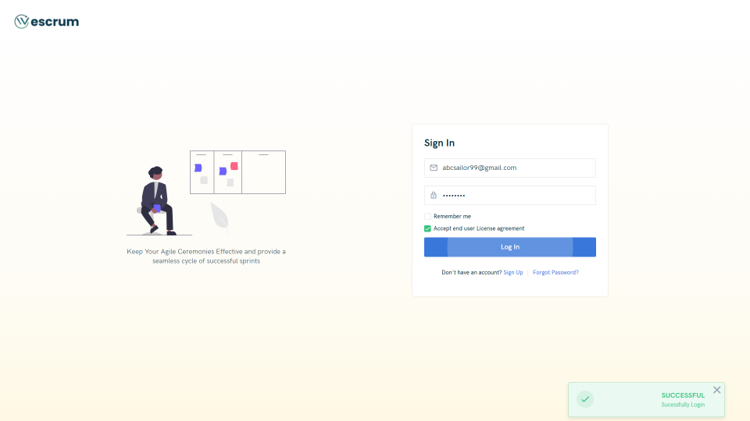

Figure 6.5 Admin User Page

Admin Side Login Page.

* **Forget Password**

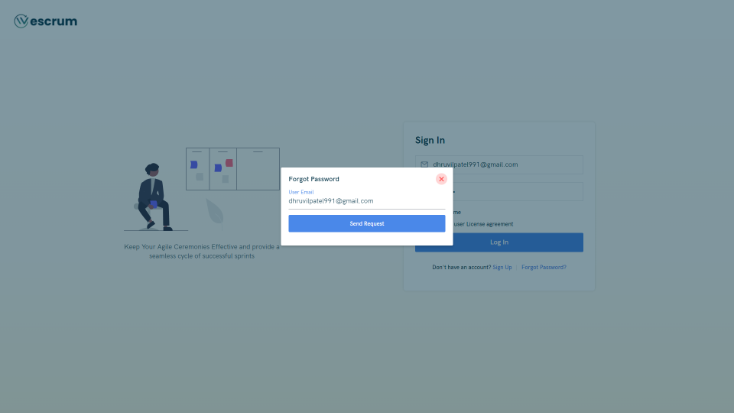

Figure 6.6 Forget Password Page

Forgot Password page.

* **Admin Dashboard**

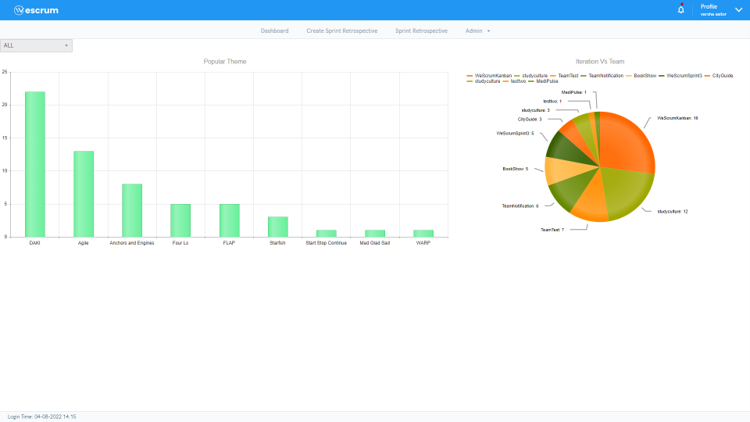

Figure 6.7 Admin Dashboard Page

Admin (Scrum Master) side Landing Page.

* **Create Retrospective Page**

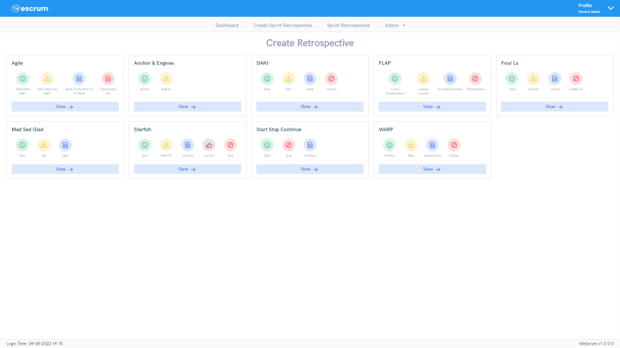

Figure 6.8 Creatre Retrospective Page

Scrum Master can create a Retrospective Page.

* **Select Retrospective**

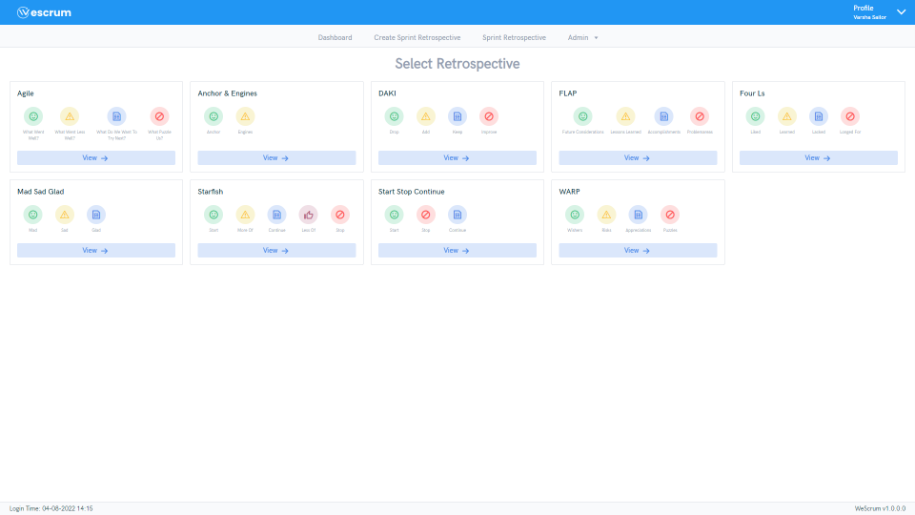

Figure 5.9 Select Retrospective Page

Already created Retrospective can be viewed in Select Retrospective.

* **Resource Management**

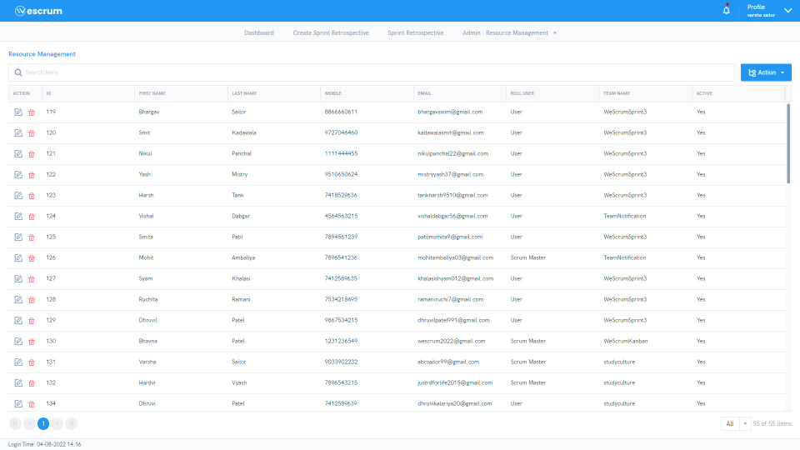

Figure 6.10 Resource Management Page

Scrum Master can add Users.

* **Team Configuration**

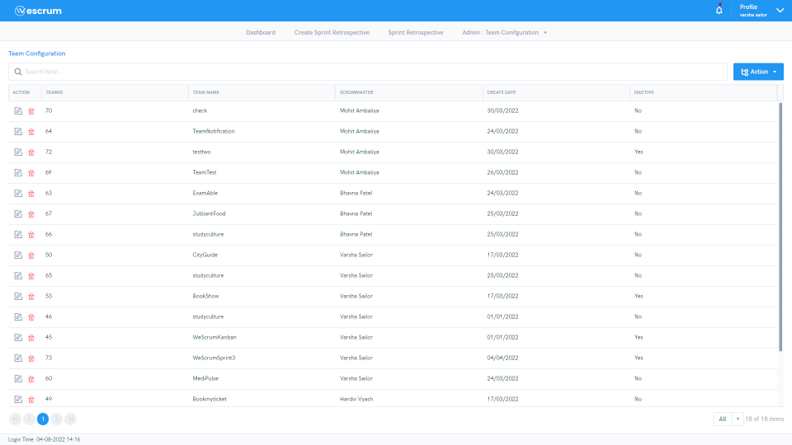

Figure 6.11 Team Configuration Page

Scrum Master can assign Team to all the User.

* **Iteration Management**

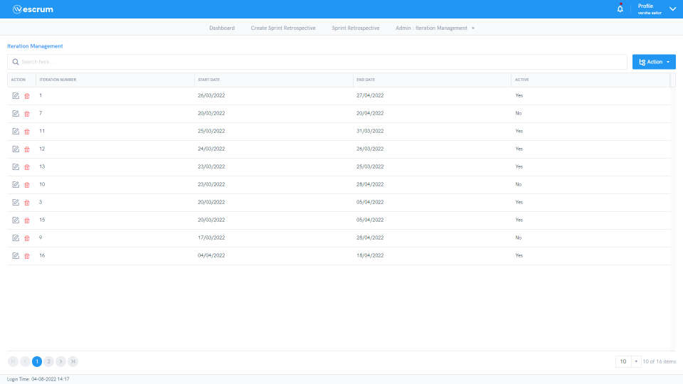

Figure 6.12 Iteration Management Page

Scrum Master can add Iteration.

* **Play Retrospective**

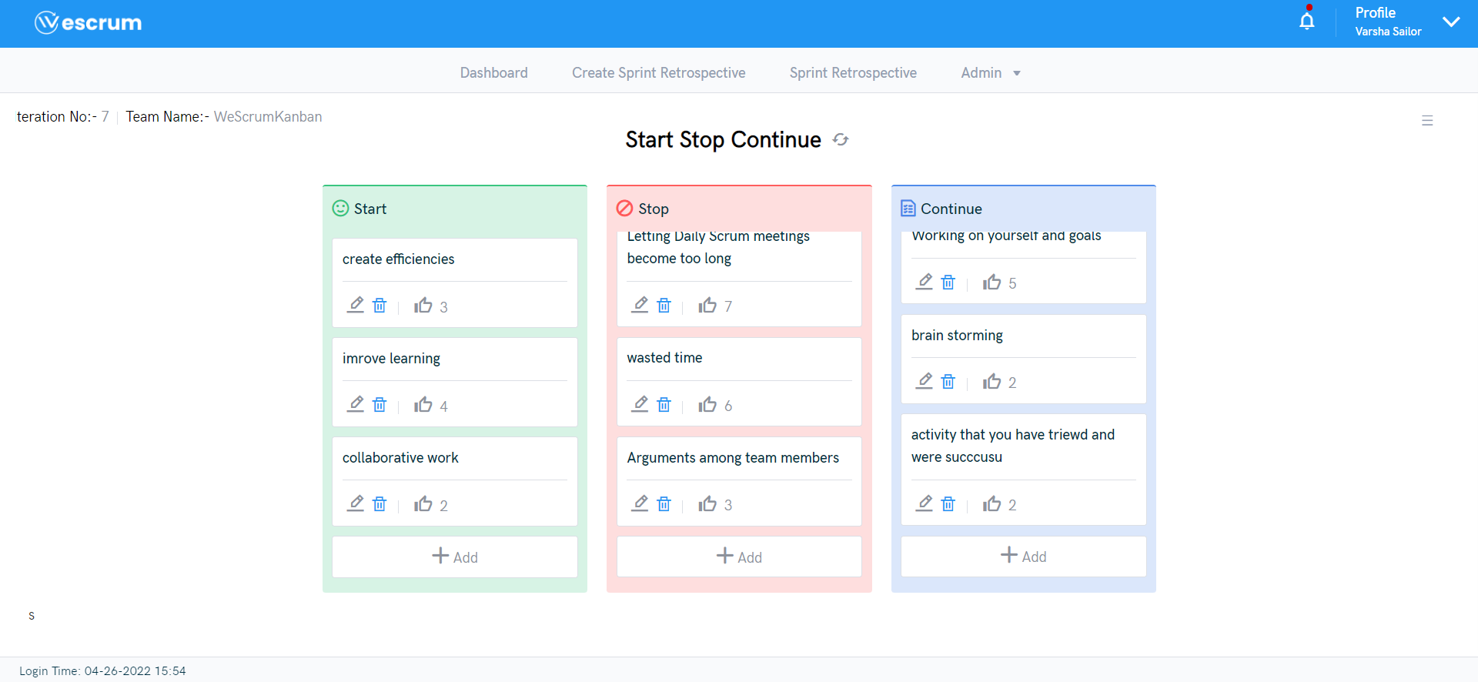

Figure 6.13 Play Retrospective Page

Scrum Master and User can add,Modify and Delete comments and also do vote by using Like button.

# Testing

## 7.1 Test Cases and Results

Sample test cases are given as below in :

Table 7. Test Cases

|  |  |  |  |  |  |
| --- | --- | --- | --- | --- | --- |
| **TestID** | **Case** | **Test Data** | **Expected Result** | **Actual Result** | **Pass/Fail** |
| 1 | **User Interface** | N/A | UI should be perfect | Click on all buttons and check if they are working or not | Pass |
| 2 | **Required Fields** | N/A | * should show asking for mandatory field | Do not enter any value in mandatory field and click on create manager | Pass |
| 3 | **Email validation** | N/A | While creating manager and delivery person enter duplicate email then show the validation message | Show the email already taken message | Pass |
| 5 | **Duplicate Data** | N/A | Manager upload excel file if it contains the duplicate data then shows the message duplicate data | Please select unique data and failed to upload | Pass |
| 6 | **LogIn Validation** | N/A | If Manager and Delivery person blocked by admin so thay can not be login | You are blocked message shows | Pass |
| 7 | **File validation** | A.pdf | Manager upload file except excel then dhould gave the message og upload excel file | Please upload an excel file message shows | Pass |
| 8 | **Wrong url** | N/A | If manager enter wrong url in browser than shows Requested path not found | Requested Path not found | Pass |
| 9 | **Email Validation** | test@gmail.com | User should be prompted with a message that email already exists. And should be asked to login instead. | Enter an already existing email address and click on signup | Pass |
| 10 | **Phone number validation** | 12#4s35 | User should be prompted to enter a valid phone number | Enter any invalid number and then click signup | Pass |
| 11 | **Phone number validation** | 9876543210 | User should not be prompted with warning | Enter any valid number and then click sign up | Pass |
| 12 | **Phone number validation** | +1 9876543210 | It should not show any validation message | Enter a mobile number with + and country code applied | Pass |
| 13 | **Password Validation** | HelloWorld | It should prompt the user to enter a value between 8 to 16 characters | Enter a password with less than 8 characters | Pass |
| 14 | **Password Validation** | Helloworldinanawesomeway | It should prompt the user to enter a value between 8 to 16 characters | Enter a password with more than 16 characters | Pass |
| 15 | **Password Validation** | HelloWorld | It should prompt the user to enter a password having alphanumeric characters | Enter a password between 8 to 16 characters but non-alphanumeric | Pass |
|  |  |  |  |  |  |
|  |  |  |  |  |  |
|  |  |  |  |  |  |
| 16 | **Password Validation** | HelloWorld123 | It should prompt the user to enter a valid password having a special character | Enter an alphanumeric password between 8 to 16 characters but without special character | Pass |
| 17 | **Password Validation** | HelloWorld@123 | It should not give any error and signup should be successful | Enter an alphanumeric password between 8-16 characters and having a special character | Pass |
| 18 | **User Interface** | NA | It should help the user to navigate between the fields | Press the tab button | Pass |
| 19 | **User Interface** | NA | The enter should act as a substitue for the click and user should be successfully signed up. | Press the enter button while selection for Signup is made | Pass |
| 20 | **User Interface** | NA | The cursor should adjust according to the field like ⌶, hand cursor, pointer, etc. | Point the cursor to various fields like text input, button, dropdown | Pass |

# Conclusion and Discussion

1. **Overall Analysis of Internship**

During an internship I got chance to sharpened my technical and non-technical skills. Learned team-work, leadership skills, active participation etc. Also worked on live project with agile methodology.

1. **Date of Surprise visit by institute mentor**

Date 1:

Date 2:

1. **Dates of Continues Evaluation**
2. **Problem Encountered and Possible solution**
   * + - **Problems**
         1. In “Find Doctor” module faced issue of design cards of doctor.
         2. In design with Kendo components.
         3. In “Book Appointment” module faced issue of date time validation. and binding of confirmation email with .NET MVC
         4. 4. In “User Profile” module faced issue with edit profile image.
       - **Solutions**
         1. Communicated with UI/UX team member of company
         2. Searched and watched several videos of KendoUI
         3. Searched and implemented binding of SMTP with .NET MVC and web API
         4. Communicated with guide
3. **Summary of Internship**

It was the good experience to work in company with live project and work under the guidance of product manager and scrum masters. Have learned new front-end and backend programming languages and implemented it in project. Also developed small applications in training duration. Learned about Agile methodology and Scrum framework and worked on project in sprint with different roles. Attended sessions on “college to corporate” life and attended a workshop on “The Ultimate Agile Scrum Kickstart”.

1. **Conclusion of Project**

We Scrum Kanban is an application which would be useful for managing project development in sprints so the tasks would be handled in strategic manner. Through the execution of project, we understood scrum methodologies and agile development approach, its principles and how team delivers work in small, but consumable, increments. The application is also used by team and team members as team can retrospect its methodologies and impediments so team can achieve goals and eventually grow project development skills. Through this project we learnt how APIs are created and consumed, how requests are sent through interfaces and manipulated by controller in MVC architecture.

References

**Web references**

1. [Online] <https://www.tutorialsteacher.com/csharp> [Date Accessed: 03 JAN 2022].
2. [Online] <https://www.tutorialsteacher.com/mvc> [Date Accessed: 10 JAN 2022].
3. [Online] <https://www.tutorialsteacher.com/webapi> [Date Accessed: 17 JAN 2022].
4. [Online] <https://riptutorial.com/winforms> [Date Accessed: 24 JAN 2022].
5. [Online] <https://www.rabbitmq.com/getstarted.html> [Date Accessed: 31 JAN 2022].
6. [Online] <https://redis.io/commands> [Date Accessed: 14 FEB 2022].